INTERNATIONAL TRADE COMMISSION

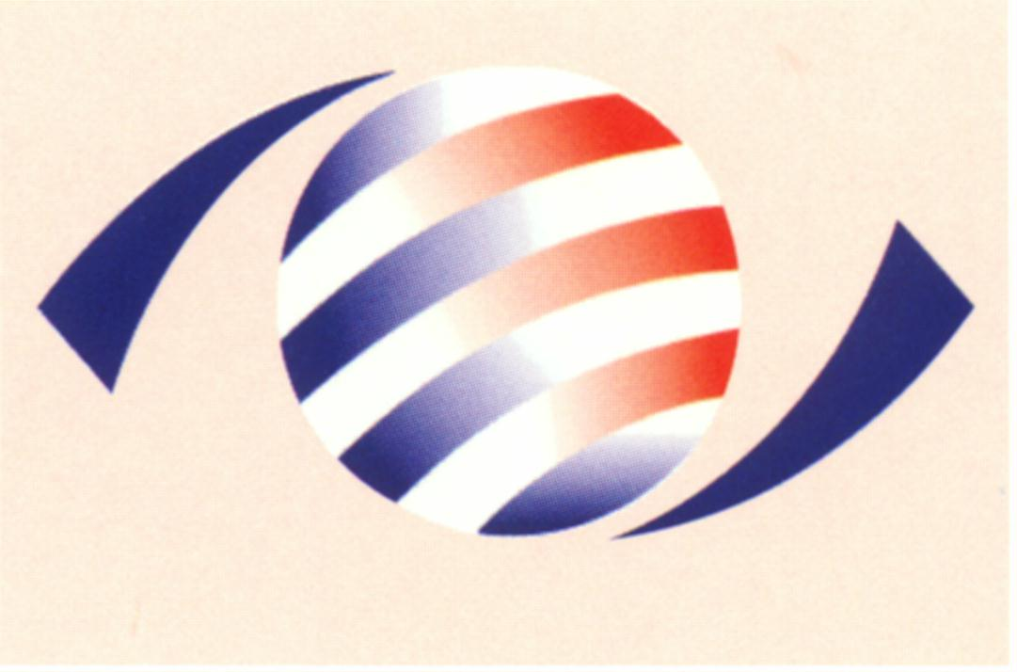
MINISTRY OF ECONOMIC AFFAIRS
8F., No.317, Songjiang Rd., Jhongshan TEL: 886-2- 2506-6670, ext. 560
District, Taipei City 10483, FAX: 886-2- 25029557
Taiwan(R.O.C.) e-mail : itc@mail.moeaitc.gov.tw
MOEAITC-ID-10100009610
Date: Mar. 29, 2012

RE: Antidumping Case on Hot Rolled Steel Plate

COMPANY NAME:
ADDRESS:
TELEPHONE NUMBER:
FACSIMILE NUMBER:

To whom it may concern:

In compliance with the decision of the Ministry of Finance (MOF) to initiate the preliminary investigation of the antidumping case on Hot Rolled Steel Plate from Korea and India, the International Trade Commission (ITC) of the Ministry of Economic Affairs is hereby sending you this summarized English inquiry along with the original copy of our official letter in Chinese.

Background

China Steel Corporation on behalf of the domestic industry filed a petition on November 14, 2011 with the MOF to impose antidumping duties on Hot Rolled Steel Plate from Korea and India. The MOF determined to initiate the investigation and transferred this case to the ITC on March 26, 2012 for preliminary injury investigation. The ITC, in accordance with Article 11 and Article 19 of the Regulations Governing the Implementation of the Imposition of Countervailing and Anti-Dumping Duties, therefore instituted the preliminary injury investigation on March 28, 2012. A copy of the flowchart of the investigation procedure is enclosed. The Regulations Governing the Implementation of the Imposition of Countervailing and Anti-Dumping Duties can be found on our website: http://law.moj.gov.tw/Eng/LawClass/LawAll.aspx?PCode=G0350034&programid=256&pagestyle=2

Subject Product: Hot Rolled Steel Plate
Reference CCC Codes:
72085110100,72085110208,72085110306,72085120000,72085130008,72085140006,72085210207,72085220205,72085230203,72089010005,72089021002,72089030001,72089040009,72111410101,72111410209,72111410307,72111420207,72111430205,72111440203

Requesting Certain Information

Please provide us with the following details, and their public version for public reading, of Hot Rolled Steel Plate for the years 2007 through 2011 on an annual basis:
1. Production
2. Utilization of capacity
3. Inventory
4. Volume exported to Taiwan, with both FOB and CIF prices
5. Volume exported to third countries, with FOB prices
6. Home market shipments
7. Data projected concerning the above items for the first quarter of 2012 and the year of 2012.

Furthermore, please provide us with some brief introductory materials and annual reports of your company in English, which include information concerning company structure, manufacturing process, and product types.

In order to make preliminary injury determination within 40 days, which is specified in our regulation, please return the required data and materials to us no later than April 11, 2012, by fax, airmail, or e-mail. Although failing to submit the required data on time in the preliminary injury investigation phase shall not be prejudicial to the definitive injury determination, your cooperation would be advantageous to your company and is therefore strongly encouraged.

If you have any questions about this case, please contact the following correspondents.
Ms. Chen (Yu-Hui Chen) Tel: 886-2-2506-6670 ext. 560
Ms. Liang (Ming-Chu Liang) Tel: 886-2-2506-6670 ext. 504

Sincerely yours,
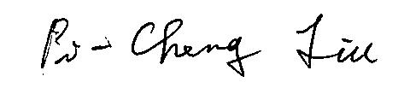

Pi-Cheng Liu
Director, Investigation Division

Enclosure

Cc:
Ministry of Foreign Affairs
Economic Division, Taipei Mission in Korea
Economic Division,Taipei Economic and Cultural Center in India
Korean Mission in Taipei
India-Taipei Association

ANTIDUMPING AND
COUNTERVAILING DUTY
SYSTEM
Petition
Receipt of Petition
Decision to initiate
investigation
(MOF)
(MOF)
Consultation with
relevant agencies
Rejection
(40 days)
Injury investigation
by MOEA
Dumping & subsidy
Investigation by MOF
Preliminary
determination on injury
(40 days)
Preliminary determination
on dumping & subsidy
(MOF)
(70 days)
Final determination on dumping & subsidy
(60 days)
Provisional measures
(MOEA)
Final determination
on injury
(40 days)
(MOEA)
Imposition of AD or CVD
(MOF)
(MOF)
(10 days)
* Days between events shown above may be extended up to one half longer, if necessary.

