INTERNATIONAL TRADE COMMISSION


MINISTRY OF ECONOMIC AFFAIRS
8F., No.317, Songjiang Rd., Jhongshan TEL: 886-2- 2506-6670, ext. 503
District, Taipei City 10483, FAX: 886-2- 25029557
Taiwan(R.O.C.) e-mail : itc@mail.moeaitc.gov.tw

MOEAITC-ID-10100015151
May 24, 2012
RE：Suspension of Preliminary Injury Investigation of Antidumping Case on Carbon Steel Cold Rolled Steel Flat Products

( COMPANY NAME )
( ADDRESS )
( TELEPHONE NUMBER )
( FACSIMILE NUMBER )

To whom it may concern:

In compliance with the decision of the Tariff Commission of the Ministry of Finance (MOF) responding to the applicant’s retracting the antidumping case on Carbon Steel Cold Rolled Steel Flat Products from China and Korea, the ITC is hereby sending you this notification, along with the original copy of our official letter in Chinese, of suspending the preliminary injury investigation from April 20, 2012, pending the MOF’s determination of whether to terminate the case.
If you have any questions about this case, please contact the following correspondents.
Ms. Lin (Su-chuan Lin) Tel: 886-2-2506-6670 ext. 503
Ms. Chang (Pi-feng Chang) Tel: 886-2-2506-6670 ext. 521

Sincerely yours,
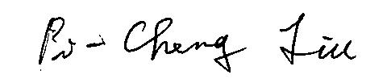

Pi-Cheng Liu
Director, Investigation Division

Enclosure

Cc:
Ministry of Foreign Affairs
Economic Division, Taipei Mission in Korea
Korean Mission in Taipei

