INTERNATIONAL TRADE COMMISSION


MINISTRY OF ECONOMIC AFFAIRS
8F., No.317, Songjiang Rd., Jhongshan TEL: 886-2- 2506-6670, ext. 511
District, Taipei City 10483, FAX: 886-2- 25029557
Taiwan(R.O.C.) e-mail : itc@mail.moeaitc.gov.tw

MOEAITC-ID-10100015171
May 24 , 2012
RE：Suspension of Preliminary Injury Investigation of Antidumping Case on Low Grade Non Grain-oriented Electrical Steel

( COMPANY NAME )
( ADDRESS )
( TELEPHONE NUMBER )
( FACSIMILE NUMBER )

To whom it may concern:

In compliance with the decision of the Tariff Commission of the Ministry of Finance（MOF） responding to the applicant’s retracting the antidumping case on Low Grade Non Grain-oriented Electrical Steel from Japan, the ITC is hereby sending you this notification, along with the original copy of our official letter in Chinese, of suspending the preliminary injury investigation from April 20, 2012, pending the MOF’s determination of whether to terminate the case.

If you have any questions about this case, please contact the following correspondents.

Mr. Sheu (Cherng-shyan Sheu) Tel: 886-2-2506-6670 ext.511
Ms. Chang (Pi-feng Chang) Tel: 886-2-2506-6670 ext.521

Sincerely yours,
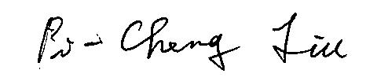

Pi-Cheng Liu
Director, Investigation Division

Enclosure

Cc:
Ministry of Foreign Affairs
Interchange Association (Japan), Taipei Office
Economic Division, Taipei Economic and Cultural Representative Office in Japan

