INTERNATIONAL TRADE COMMISSION
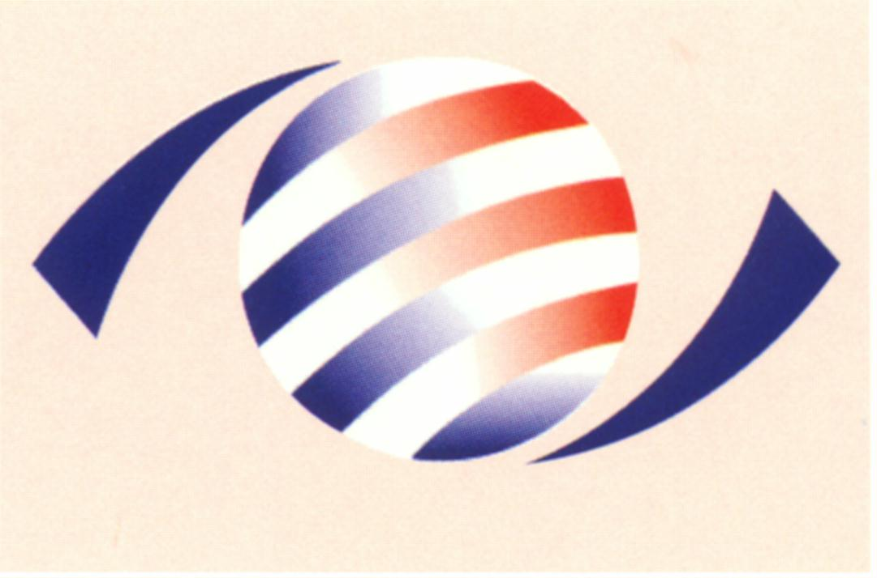
MINISTRY OF ECONOMIC AFFAIRS
8F., No.317, Songjiang Rd., Jhongshan TEL: 886-2- 2506-6670, ext. 511
District, Taipei City 10483, FAX: 886-2- 25029557
Taiwan(R.O.C.) e-mail : itc@mail.moeaitc.gov.tw

MOEAITC-ID-10100019600
July 12, 2012
RE：ITC Terminates Injury Investigation of Antidumping Case on Low Grade Non Grain-oriented Electrical Steel

( COMPANY NAME )
( ADDRESS )
( TELEPHONE NUMBER )
( FACSIMILE NUMBER )

To whom it may concern:

According to the public notice made on July 3, 2012 by the Ministry of Finance to close the antidumping case on Low Grade Non Grain-oriented Electrical Steel from Japan, the International Trade Commission is hereby sending you this notification of terminating the injury investigation, along with the original copy of our official letter in Chinese.

If you have any questions about this case, please contact the following correspondents.

Mr. Sheu (Cherng-shyan Sheu) Tel: 886-2-2506-6670 ext.511
Ms. Chang (Pi-feng Chang) Tel: 886-2-2506-6670 ext.521

Sincerely yours,
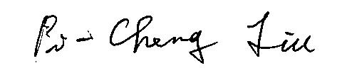

Pi-Cheng Liu
Director, Investigation Division

Enclosure

Cc:
Ministry of Foreign Affairs
Interchange Association (Japan), Taipei Office
Economic Division, Taipei Economic and Cultural Representative Office in Japan

