INTERNATIONAL TRADE COMMISSION

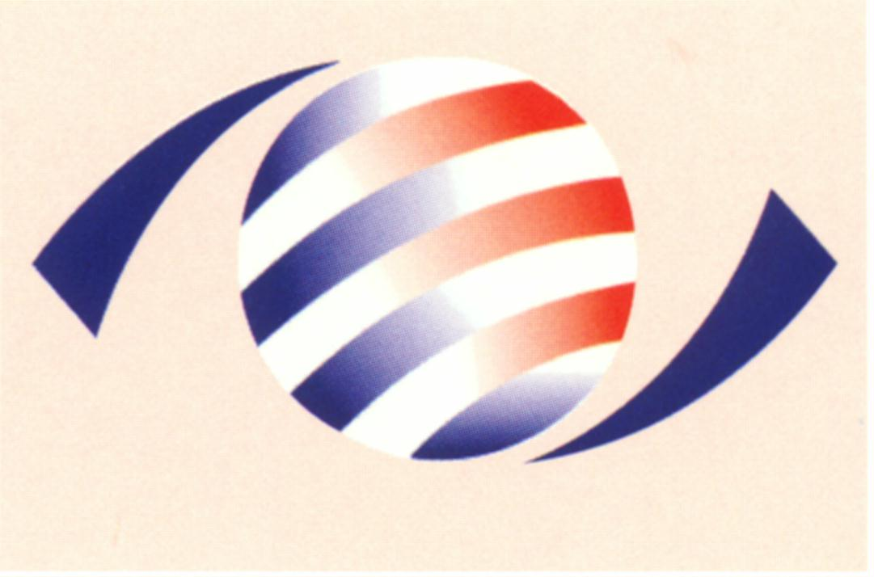
MINISTRY OF ECONOMIC AFFAIRS
8F., No.317, Songjiang Rd., Jhongshan TEL: 886-2- 2506-6670, ext. 524
District, Taipei City 10483, FAX: 886-2- 25029557
Taiwan(R.O.C.) e-mail : itc@mail.moeaitc.gov.tw

MOEAITC-ID-10100030411
Nov. 16, 2012
RE：Excluding the Pending Period from the Period of Final Injury Investigation on Antidumping Case on Coated Paper

( COMPANY NAME )
( ADDRESS )
( TELEPHONE NUMBER )
( FACSIMILE NUMBER )

To whom it may concern:
Due to the applicant’s request on Oct. 29, 2012 of retracting the antidumping case on Coated Paper from China, Japan, Korea and Finland, the ITC is hereby sending you this notification, along with the original copy of our official letter in Chinese, that the period pending the MOF’s determination of whether to terminate the case will be excluded from the period of final injury investigation.

If you have any questions about this case, please contact the following correspondents.

Ms. Kuo (Miao-rong Kuo) Tel: 886-2-2506-6670 ext. 524
Ms. Liang(Ming-chu Liang) Tel: 886-2-2506-6670 ext. 504

Sincerely yours,

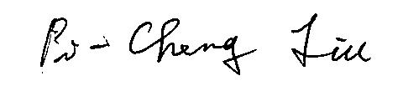
Pi-Cheng Liu
Director, Investigation Division

Enclosure

Cc:
Ministry of Foreign Affairs
Economic Division, Taipei Economic and Cultural Representative Office in Japan
Japan Paper Association
Japan Paper Exporter’s Association
Korea Paper Manufacturers’ Association
Economic Division, Taipei Mission in Korea
Finnish Forest Industries Federation
Commercial Division, Taipei Representative Office in Finland
Interchange Association (Japan), Taipei Office
Korean Mission in Taipei
European Economic and Trade Office
Finland Trade Center (FINPRO)
Permanent Mission of the Separate Customs Territory of Taiwan, Penghu, Kinmen and Matsu to the World Trade Organization

