INTERNATIONAL TRADE COMMISSION

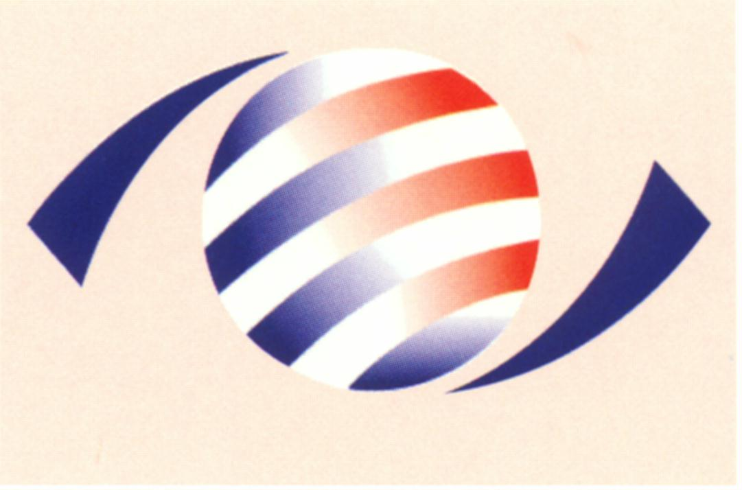
MINISTRY OF ECONOMIC AFFAIRS
8F., No.317, Songjiang Rd., Jhongshan TEL: 886-2- 2506-6670, ext. 524
District, Taipei City 10483, FAX: 886-2- 25029557
Taiwan(R.O.C.) e-mail : itc@mail.moeaitc.gov.tw

MOEAITC-ID-10100032500
Dec. 17, 2012
RE：ITC Terminates Injury Investigation of Antidumping Case on Coated Paper

( COMPANY NAME )
( ADDRESS )
( TELEPHONE NUMBER )
( FACSIMILE NUMBER )

To whom it may concern:

According to the public notice made on Dec. 11, 2012 by the Ministry of Finance to close the antidumping case on Coated Paper from China, Japan, Korea and Finland, the International Trade Commission is sending you this notification of terminating the injury investigation thereof, along with the original copy of our official letter in Chinese.

If you have any questions about this case, please contact the following correspondents.
Ms. Kuo (Miao-rong Kuo) Tel: 886-2-2506-6670 ext. 524
Ms. Liang (Ming-chu Liang) Tel: 886-2-2506-6670 ext. 504

Sincerely yours,
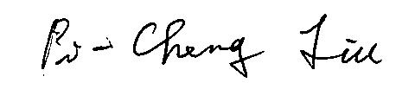

Pi-Cheng Liu
Director, Investigation Division

Enclosure

Cc:
Ministry of Foreign Affairs
Economic Division, Taipei Economic and Cultural Representative Office in Japan
Japan Paper Association
Japan Paper Exporter’s Association
Korea Paper Manufacturers’ Association
Economic Division, Taipei Mission in Korea
Finnish Forest Industries Federation
Commercial Division, Taipei Representative Office in Finland
Interchange Association (Japan), Taipei Office
Korean Mission in Taipei
European Economic and Trade Office
Finland Trade Center (FINPRO)

