INTERNATIONAL TRADE COMMISSION

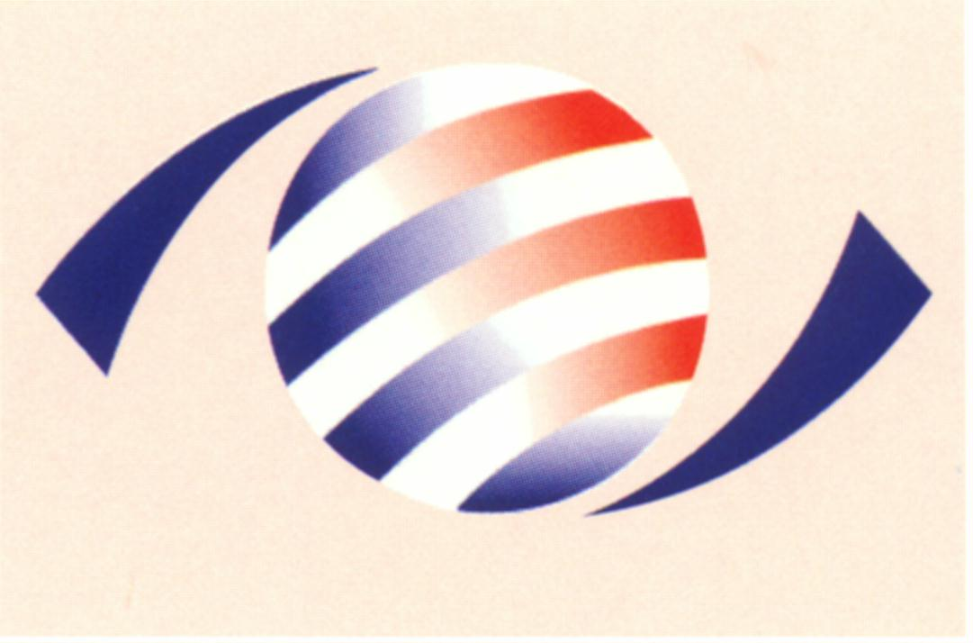
MINISTRY OF ECONOMIC AFFAIRS
8F., No.317, Songjiang Rd., Jhongshan TEL: 886-2- 2506-6670, ext. 524
District, Taipei City 10483, FAX: 886-2- 25029557
Taiwan(R.O.C.) e-mail : itc@mail.moeaitc.gov.tw

MOEAITC-ID-10100029510
Oct. 12, 2012

RE：Final Injury Investigation of the Antidumping Case on Coated Paper from China, Japan, Korea and Finland

( COMPANY NAME )
( ADDRESS )
( TELEPHONE NUMBER )
( FACSIMILE NUMBER )

To whom it may concern:

Following an affirmative final determination by the Ministry of Finance ( MOF ) that imports of Coated Paper from China, Japan, Korea and Finland are being dumped in the R.O.C., the International Trade Commission ( ITC ) of the Ministry of Economic Affairs instituted its final investigation on Sep. 27, 2012 to determine whether the domestic industry concerned in the R.O.C. is materially injured, or is threatened with material injury by the above mentioned dumped imports.

Enclosed is the original copy of our official letter in Chinese.

If you have any questions about this case, please contact the following correspondents.
Ms. Kuo (Miao-rong Kuo) Tel: 886-2-2506-6670 ext. 524
Ms. Liang(Ming-chu Liang) Tel: 886-2-2506-6670 ext. 504

Sincerely yours,

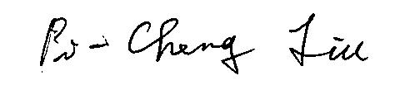

Director, Investigation Division

Enclosure

Cc:
Ministry of Foreign Affairs
Economic Division, Taipei Economic and Cultural Representative Office in Japan
Japan Paper Association
Japan Paper Exporter’s Association
Korea Paper Manufacturers’ Association
Economic Division, Taipei Mission in Korea
Finnish Forest Industries Federation
Commercial Division, Taipei Representative Office in Finland
Interchange Association (Japan), Taipei Office
Korean Mission in Taipei
Finland Trade Center (FINPRO)

